Using Our Candles & Wax Melts on Your Skin
- Light your candle or wax melt
- Wait until you have a pool of wax
- With a teaspoon and scoop out a small amount of the melted wax
- Massage it into your skin immediately (the cooler burn rate of plant wax means it won't burn you).
The melted wax may be used on the hands, feet, legs, arms, back, stomach, neck and shoulders.
Important - due to their rich formulation, melted wax is not suitable for use on the face.
Other uses:
- Rub into your cuticles for a nourishing nail treatment
- To help with fly away hair, pop a "teeny weenie" bit on the palms of your hands and smooth onto the ends of your hair

Candle Care Tips
Trim your wick
Trim your wick to approximately ½ cm before every use which:
- Prevents any black soot - wicks that are too long cannot draw wax all the way up to the top, so the bare wick will start to burn
- Wick trimmers are are more effective and gentler than scissors or breaking with your fingers
- Even with Altruis Living cotton wicks and our natural wax blend, you will see some soot if your wicks start burning themselves
- Gives your candle a longer burn time
- Applies to brand new candles that don't necessarily come pre-trimmed
The best way to extinguish your candle is to use a wick dipper or snuffer
- They are a more effective and gentler way to extinguish candles
- Safer and easier to put out the flame
- It prevents wax spray and smoke
- It prevents the wick being buried in the wax making it hard to light the candle again
How to use a wick dipper
- Use the dipper to hook the wick and extinguish the candle in the wax
- The flame goes out with no smoke or soot
- Gently ease the wick back up, the wick is then coated in wax and primed for the next lighting
Our Candle Wick Trimmer & Dipper Tool Set is available in our shop.
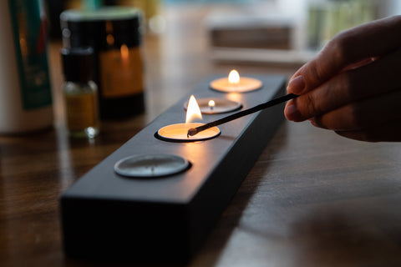
Image provided by High Life North

To avoid getting a tunnel effect on your candle
- The first burn of your candle is the most important and the wax MUST pool to the edge of the container on the 1st burn
- Please burn for 2-4 hours depending on the size to ensure you get the correct pooling
- Wax has a memory - if your candle doesn't burn to the edges, it will start to tunnel and burn unevenly, the next time it won't last as long
- Keep away from airstreams like air conditioning, vents, windows, or fans

